**SVKM’S NMIMS**

**MUKESH PATEL SCHOOL OF TECHNOLOGY MANAGEMENT& ENGINEERING**

**(Campus Name)**

Academic Year: 2020-2021

# **Practical 3- Shortest Job first scheduling algorithm**

|  |  |  |
| --- | --- | --- |
| Name: Arjun Mehta | Roll_No: K036 | SAP-ID |
| B. Tech CSE Cybersecurity |  |  |

Dear all,

Kindly complete the following task with your name in output file also attach the C program with the file.

Find the Turnaround time and Average Turnaround time.

Find the Waiting time and Average Waiting time.

1. Completion Time: Time at which process completes its execution.
2. Turn Around Time: Time Difference between completion time and arrival time. Turn Around Time = Completion Time – Arrival Time
3. Waiting Time(W.T): Time Difference between turn around time and burst time.   
   Waiting Time = Turn Around Time – Burst Time

**CODE:**

def sjf_scheduling():

n = int(input("Enter number of processes: "))

if n <= 0:

print("Number of processes must be greater than 0.")

return

bt = []

p = []

wt = []

tat = []

print("\nEnter Burst Time for each process:")

for i in range(n):

burst_time = int(input(f"P{i+1}: "))

bt.append(burst_time)

p.append(i + 1)

for i in range(n - 1):

pos = i

for j in range(i + 1, n):

if bt[j] < bt[pos]:

pos = j

bt[i], bt[pos] = bt[pos], bt[i]

p[i], p[pos] = p[pos], p[i]

print("\n\nk036 Arjun Mehta\n")

wt.append(0)

total_wt = 0

for i in range(1, n):

wt.append(sum(bt[:i]))

total_wt += wt[i]

avg_wt = total_wt / n

total_tat = 0

print("\nProcess\tBurst Time\tWaiting Time\tTurnaround Time")

for i in range(n):

tat.append(bt[i] + wt[i])

total_tat += tat[i]

print(f"P{p[i]}\t{bt[i]}\t\t{wt[i]}\t\t{tat[i]}")

avg_tat = total_tat / n

print(f"\nAverage Waiting Time = {avg_wt:.2f}")

print(f"Average Turnaround Time = {avg_tat:.2f}")

sjf_scheduling()

**OUTPUT:**

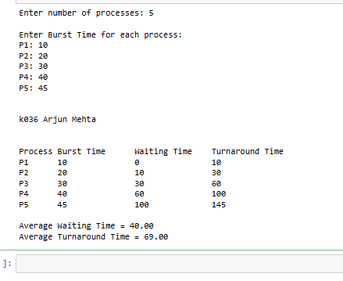

### **Example 1:-**

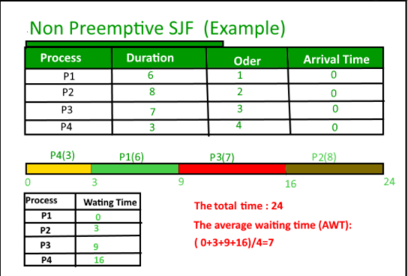

**Example 2:-**

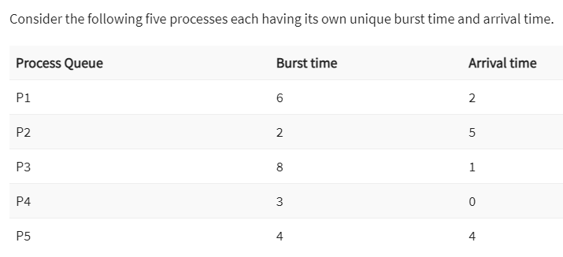

## **Conclusion: -**

Write your observation about Shortest Job algorithm. How it is better than First come first serve algorithm.

The algorithm schedules processes in the order in which the shortest job is done first. It has a minimum average waiting time. The average waiting time for given set of processes is minimum in SJF than FCFS which in turn leads to higher effectiveness of the system therefore its better than FCFS.